Michael Clingerman
Lead Product Designer / UX Research

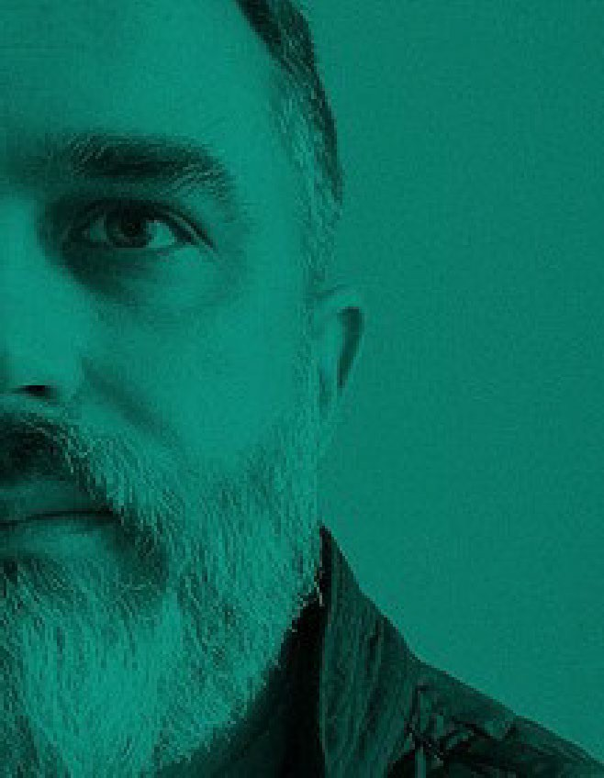An experienced Product Designer, SCRUM Master, and Researcher with a passion for details, driving and achieving broad visions.
I love building UX teams. My strong suits are as a product visionary, innovation, and prototyping. I have a diverse skill set as a Product Designer and creative with experience in IA, UX, Project Management, Branding, and Research. Deep understanding of digital media strategy and able to drive execution in an agile environment. Experienced in agency style fulfillment, product mockups, and collaborative teamwork. I have a crisp “no-frills” communications style with an entrepreneurial management background. Experience in ethnographic, remote moderated and unmoderated UX research methodologies and an interest in voice user experience VUX.

Professional Experience
2021.05 - Present Lead Product Design Research & Strategy

VoiceOps - San Francisco
Responsible for leading a StartUp Product Design Strategy and usability research planning while mentoring a team, leading discovery, ideation, future-state, general project management/reporting, and ongoing usability research.
Software: Figma Enterprise

Strategy and Industry Research
Hiring product team members and front/back-end developers that can assist in the rapid development and deployment of agile UX.
“Story Mapping” goals into actionable Agile UX for fast testing with customers. Identifying 3rd party solutions for partnerships and leading customer interviews. Using standard qualitative data collection practices via ethnographic observation to quickly identify customer workflow challenges in the MVP.
Delivered actionable findings analysis recommendations to the product team for rapid improvements and fast feedback.
Identified initial product improvement KPIs for customer satisfaction related to the usability and efficiency of the product for coaching and behavioral analysis.
Delivering agile tranches of UX for a lien front-end team to deploy Sprint to Sprint.

2018.07 - 2021.04 Director UX Design & Research

OpSec Security
Responsible for UX strategy, research plan in alignment with the ongoing sprint cycles. Mentoring a small team, leading discovery, ideation, future-state, general project management/reporting, and ongoing usability research.
Software: Figma Enterprise (6-teams)

Discovery & Research
Scheduled initial qualitative observations onsite in Boise from a sampling of 200+ analysts. Produced findings for C-Level staff. Co-led customer interviews, data collection audit of customer exit-interviews, and produced findings for C-Level staff. Regular UX observations of mockups and qualitative data collection with analysts and testing. Qualitative research to achieve efficiency gains in major workflows. KPI creation and delivery.

Team/Department building
Mentored junior UX designers to think comprehensively E2E to expedite delivery time and communications skills.

Design
Ongoing improved UX design efforts to visual scan-ability of the data-grid thereby reducing the cognitive load for analysts.
Designed/Tested a series of prototypes leading to future-state design for Brand- protection responsible for $70M in annual revenues.

Personal Info

Address
3011 78th Avenue SE #312 Mercer Island, WA 98040

Phone
408.838.2848

E-mail
artonthemind@gmail.com

Portfolio Site Password
V35bmvC87KgM

Portfolio Site
https://www.mcdesignthinking.com

LinkedIn https://www.linkedin.com/in/mclinger man/

Education
2018.05 - 2018.07

(MIT) Massachusetts Institute of Technology -
(HCI Certificate)
- Human-Computer Interaction for User Experience Design - Certification
- Exposure to Eight core faculty from MIT and their research exploring HCI and their research.
- Explored solutions around heads up display navigation and digital functionality for BMW
2019.04 - 2019.06

NuCamp Code Bootcamp -

2017.03 -2018.07 Lead Product Design & Research

Deloitte - Bersin by Deloitte
Bersin, a HR Research publisher and advisory services firm offering enterprise learning, talent management, and strategic HR solutions adding projected $250M of revenue to a
$1.3B revenue stream in HR consulting for the Human Capital division.

Discovery and Research
Lead Customer interviews and qualitative data collection and analysis Produced findings reports and design change recommendations to team and stakeholder Regular formative UX observations of mockups and qualitative data collection

Design
Lead the redesign of a vast PDF database (HR research and publications) to a converted mobile first HTML based Kindle-Style E-Reader. (Supporting 4x viewports responsive) Lead the redesign of an elastic search system UX with insights to search term use-cases in search results.
Ideation and prototyped a D3JS driven PDF library and UI framework call Bersin-Oracle. Oversaw and drove the formative qualitative data collection to justify the project.

2016.07 - 2017.08
Seattle Washington -
Certificate
HTML5 / CSS / JavaScrip Bootcamp
- Exposure to intermediate JS usage. Creation of a minor JS video game.
2016.04 - 2018.06
Kent State University, IA UX Design & Research, MS
- GPA of 3.9 with Honors
- Golden Key Honour Society
- Amazon guided 12-week (VUI) Voice User Interface Thesis project "Alexa enabled Refrigerator" for Amazon Foods
2016.03 - present
CSM Certified SCRUM Master
- Current
Scrumalliance.org - Certificate ID: 501000 / Membership ID: 39003099
1990 - 1995
Savannah College Art and Design, Graphic Design, BFA Scholarship grant for portfolio submission to entrance board.
1990 - 1995
Savannah College Art and Design, Art History, Minor Focus on Greek and Roman art and
architecture
Awards / Grants
2016
Golden Key International Honour Society - 2016 3.9 GPA in graduate program UXD
2015.12
Microsoft BizSpark Grant Recipient –
12/2015 StuffRescue™ - Social good tech startup
Advisory / Board Seats
2021.08
Digital Product Advisor - The VirusIQ mobile helps detect, prevent and contain the spread of viruses for airlines, VirusIQ enables passengers to perform screening tests prior to check-in in under 5 minutes.
Enabling airlines to resume business
activity safely.

2016.02 - 2016.08

2015.06 - 2016.08

2011.05 - Present

2005 - 2007

Product Design

SAP - Abakus (Start-Up) SF
Lead a full Abakus (acquired by SAP) platform redesign with founders and developers based on client usability study and moderated testing.
Monitored customer understanding and comprehension of scoring dashboards.

Lead Product Design (Contract Under NDA) Principal Designer

Tremor (Start-Up) NYC/Bermuda
Disruptive Re-Insurance Industry blockchain solution – Led UX for a ground-up full- platform design and launch with founder and a lean team of contractors.

Lead UX & UI – PI, SCRUM

MasterMicrosoft - OneRM Office Division
Microsoft Office Division OneRM a Big Data CRM - A multi-channel marketing campaign solution driving an estimated $1 billion in business value. Merging usage- data live in CRM. Largest Azure hosted account in history 2016 processing 650k+ transactions per second of Microsoft customer subscriber usage data.

Discovery & UX Research
- Led a full platform redesign based on client usability study and testing.
- Observed improved customer comprehension of scoring dashboards.
- Started UX ethnographic workstation for regular observation of new feature testing.
- Conducted user research, interviews, and crafted informed UX decision making strategy for leadership along with regular user story writing with SCRUM teams.

Product Design
- Responsible for guiding leading UX/UI ideation.
- Managed 2 teams of front-end developers as a PM, SCRUM master, and UXD.
- Crafting a UX Strategy, roadmap creation, timeline.
- Axure and InVision for mockups and co-creation of user flow pitches.

Strategic Business Advisor and Board Member

Treefree Solutions Inc. (Startup)
Success: Project scaling up to plant 30,000+ acres in the EU with am IKEA subsidiary manufacturer to begin replacement of 25% to 50% of wood in composites by 2024.

UXD and Industrial Designer / Manufacturer

Senet Entertainment (Startup contract)
Wharton Business School Incubator Industrial Design and Product UX Partnership w/ Bungie ® & Halo®. Designed, and manufactured linked-multiplayer-gaming mobile desks shown at 2005 Sundance Film Festival.

2003.06 - 2014

2002.04 - 2004.09

1997 - 2001

1995 - 1996

1994 - 1996

Founder – Industrial Furniture Design

Michael Sean Inc.
Created a custom modern industrial furniture design business specializing in steel fabrication and one-of-a-kind custom pieces with national distribution to Macy's Department Stores. Design/Sales/Distribution under one hood focused on NYC sales.

Founder – Operations

Sergio Davila Inc.
Co-Founder & Investor: Industrial pattern designer for national menswear collection distributed to and sold within Saks Fifth Avenue and Nordstrom.

Director of Interactive Design

Yahoo! Inc
Accomplishments: Built a team managing Y! homepage campaigns. 20% work-time role in R&D for new monetized ad solutions/features. Managed an agency- style group of designers, and engineers (5-15 headcount).

Co-Creative Director
Turner Network Television/Time Warner Inc. (SPIV.com e-zine) SPIV.com A groundbreaking Web 1.0 e-Zine focused on (6) Six lifestyle websites refreshed every 2 weeks and revitalize content daily/weekly. Team Size: 4 designers

Art Director (Freelance)

Ogilvy & Mather
Clients included - Kodak, Gulfstream Airline, and Coca-Cola, Griot's Garage, UPS, etc. Reported to the Creative Director of Atlanta office.

2017.12
Board Member - Treefree Solutions Inc. Seattle. WA - Green Composite Building Material feedstock for IKEA and other composite board companies globally. These solutions reduce tree use by as much as 1% globally YOY. Crops planted globally.
2019.09
Student Mentoring - Mentored students in the fine arts from the Bill and Malinda Gates High School.
2020 Achievement: $200K full scholarship to California College of the Arts (CCA) Veronica Dodds (4.2 GPA). (Lakeside School is a private/independent school in Seattle, Washington ranking best private high school in Washington state and 23rd best in the United
States.)
Interests
Sports - Paddle boarding, Scuba Diving, Cycling, and Yoga
Fine Art - Sculpture, large -scale painting, furniture/lighting design
Environmental improvement - Board Member for a Seattle Corp. focused on green composite building materials and R&D for IKEA.
Self-Improvement Meditation Community - Formed and lead a 2000-person spiritual meditation community in San Francisco, CA for 8 years. Built from scratch after a trip to India to experience measurable improvements from meditation
during 2003 - 2011.

Consulting Experience

Lead UX & Product Design (Thesis Project)

Amazon Foods - Alexa Refrigerator Hardware VUX Strategy and Design
Problem Statement: How might Prime users source and explore unique foods and recipes via Alexa in a kitchen consumer appliance? How to help consumers expand their educational food awareness into new types of cultural recipes.

12-Week Masters Independent Study
Amazon Advisor: Brad Gashler, Amazon Foods
Weeks 1–3: Project scope simple dialogue writing, business model, industry analysis, problem statements, sample dialogue design and wire framing.
Weeks 4–6: Simple dialogue design and wire framing, research and participant feedback on dialogs, moderated interviews, Research findings and insights from recorded interviews.
Weeks 7–12: Mental model development, topics of focus, moderated interviews and questions with participants, revisions to mental model, craft in high Fidelity Costco and integrating with Alexa skills.

Lead Product Design (Contract Under NDA) Principal Designer

Databricks - San Francisco
Led usability design and strategy with Director of Design and the VP of Customer Success. Problem - Finding a way to accurately forecast: 1. Complicated data processing projects (“DBU” Use Cases) 2. Machine processing time 3. Translate that into internal sales expectations 4.
Forecasting dollar Values on a rolling monthly and Quarterly basis. 5. Inside the Salesforce website environment.

Discovery & Design
Qualitative and observational interviews specific to multiple personas from sales to customer success along with fast paced rough concept wire framing in conjunction with a lean development team to establish multiple phases of release dates.
Hi fidelity wireframes (Figma) and clickable experiences inside of the Figma ecosystem for developer deliverables.

Lead Product Design (Contract Under NDA) Principal Designer

Deloitte Pixel
Contracted to inspire a Deloitte leadership team to generate innovative UX ideas.
Utilized design thinking tools to flush out user stories and priorities with tools including card sorting and story mapping.
Assisted with ideation sessions, vision, and UX deliverables with a large party of Deloitte upper management for funding from C-Level NY leadership.

